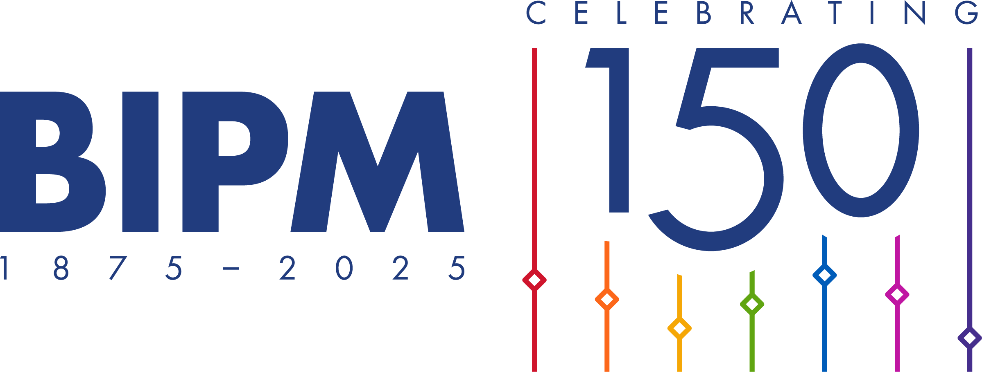
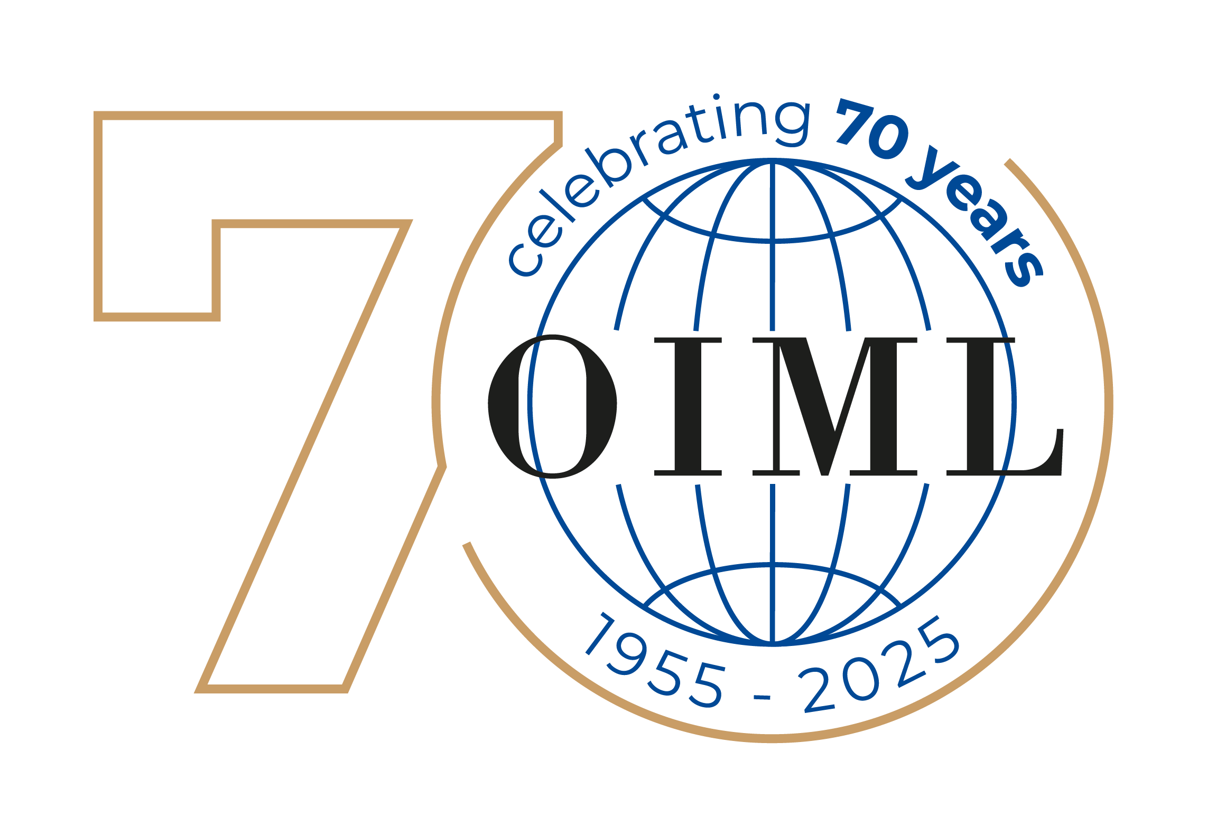

Press release
WORLD METROLOGY DAY – 20 May 2025

Measurements for all times, for all people

Release:
The 20 May is World Metrology Day, commemorating the anniversary of the signing of the Metre Convention in Paris, in 1875. This treaty provides the basis for a worldwide coherent measurement system that underpins scientific discovery and innovation, industrial manufacturing and international trade, as well as the improvement of the quality of life and the protection of the global environment.
The theme for World Metrology Day 2025 is Measurements for all times, for all people, chosen to highlight the importance of measurements in shaping our past, present and future. This theme has added significance in 2025, which marks the 150th Anniversary of the Metre Convention.
As a tribute to this milestone, World Metrology Day 2025 will be at the core of events to celebrate a century and a half of international collaboration in metrology. From ensuring fair trade and advancing scientific discovery to addressing global challenges like climate change and public health, measurements have been fundamental for progress and innovation. The theme also emphasizes inclusivity, recognizing that reliable and traceable measurements are essential for fostering equity and improving the quality of life for all people, everywhere.
Around the world, national metrology laboratories continually advance measurement science by developing and validating new measurement techniques at the necessary level of sophistication. The national metrology institutes participate in measurement comparisons coordinated by the Bureau International des Poids et Mesures (BIPM) or by the Regional Metrology Organizations, to ensure the reliability of measurement results worldwide.
The International Organization of Legal Metrology (OIML) develops International Recommendations, which aim to align and harmonize requirements worldwide in many fields. The OIML also operates the OIML Certification System (OIML-CS) which facilitates international acceptance and global trade of regulated measuring instruments.
These international metrology systems provide the necessary assurance and confidence that measurements are accurate, providing a sound basis for global trade today and helping us to prepare for the challenges of tomorrow.
World Metrology Day acknowledges and honours the contributions of individuals working in intergovernmental, regional, and national metrology organizations and institutes year-round. In November 2023, a significant milestone was reached as the UNESCO General Conference, during its 42nd Session, officially recognized the celebration on 20 May annually. Underscoring its pivotal role in advancing global scientific cooperation, this endorsement opens up new avenues to promote metrology, aligning with UNESCO's mission to build a better world through science and education.

Further information, including a message from the Directors, posters,
and a list of events, is available at
www.worldmetrologyday.org – Contact: wmd@worldmetrologyday.org

Notes for Editors:
World Metrology Day is an annual event during which the impact of measurement on our daily lives is celebrated around the world.
This date was chosen in recognition of the signing of the Metre Convention on 20 May 1875, the beginning of formal international collaboration in metrology. Each year World Metrology Day is organized and celebrated jointly by the International Bureau of Weights and Measures (BIPM) and the International Organization of Legal Metrology (OIML) with the participation of the national organizations responsible for metrology.
The international metrology community which works to ensure that accurate measurements can be made across the world endeavours to raise awareness each World Metrology Day through a poster campaign and web site. Previous themes have included topics such as measurements for the global energy challenge, for safety, for innovation, and measurements in sport, the environment, medicine and trade.

About the BIPM
The signing of the Metre Convention in 1875 created the International Bureau of Weights and Measures (BIPM) and for the first time formalized international cooperation in metrology. The Convention established the BIPM and laid the foundations for worldwide uniformity of measurement in all aspects of our endeavours, historically focusing on and assisting industry and trade, but today just as vital as we tackle the grand challenges of the 21st Century such as climate change, health, and energy. The BIPM undertakes scientific work at the highest level on a selected set of physical and chemical quantities. The BIPM is the hub of a worldwide network of national metrology institutes (NMIs) which continue to realize and disseminate the chain of traceability to the SI into national accredited laboratories and industry.
About the OIML
In 1955 the International Organization of Legal Metrology (OIML) was established as an Intergovernmental Treaty Organization in order to promote the global harmonization of legal metrology procedures with the Bureau International de Métrologie Légale (BIML) as the Secretariat and Headquarters of the OIML. Since that time, the OIML has developed a worldwide technical structure whose primary aim is to harmonize the regulations and metrological controls applied by the national metrological services, or related organizations.

